Assignment 6

(Weight: 4%)

Bandana Pachabhaiya Magar(C0916126)

Kusum Lamichhane(C0917362)

## **Objectives:**

To understand and be able to retrieve data from multiple tables

## **Instruction:**

Use SQL and the Henry Books database to complete questions 1,2 and 3 and use HR to complete the question 4.

**Question 1:**

For each book, list the book code, book title, and publisher name. Order the results by publisher name.

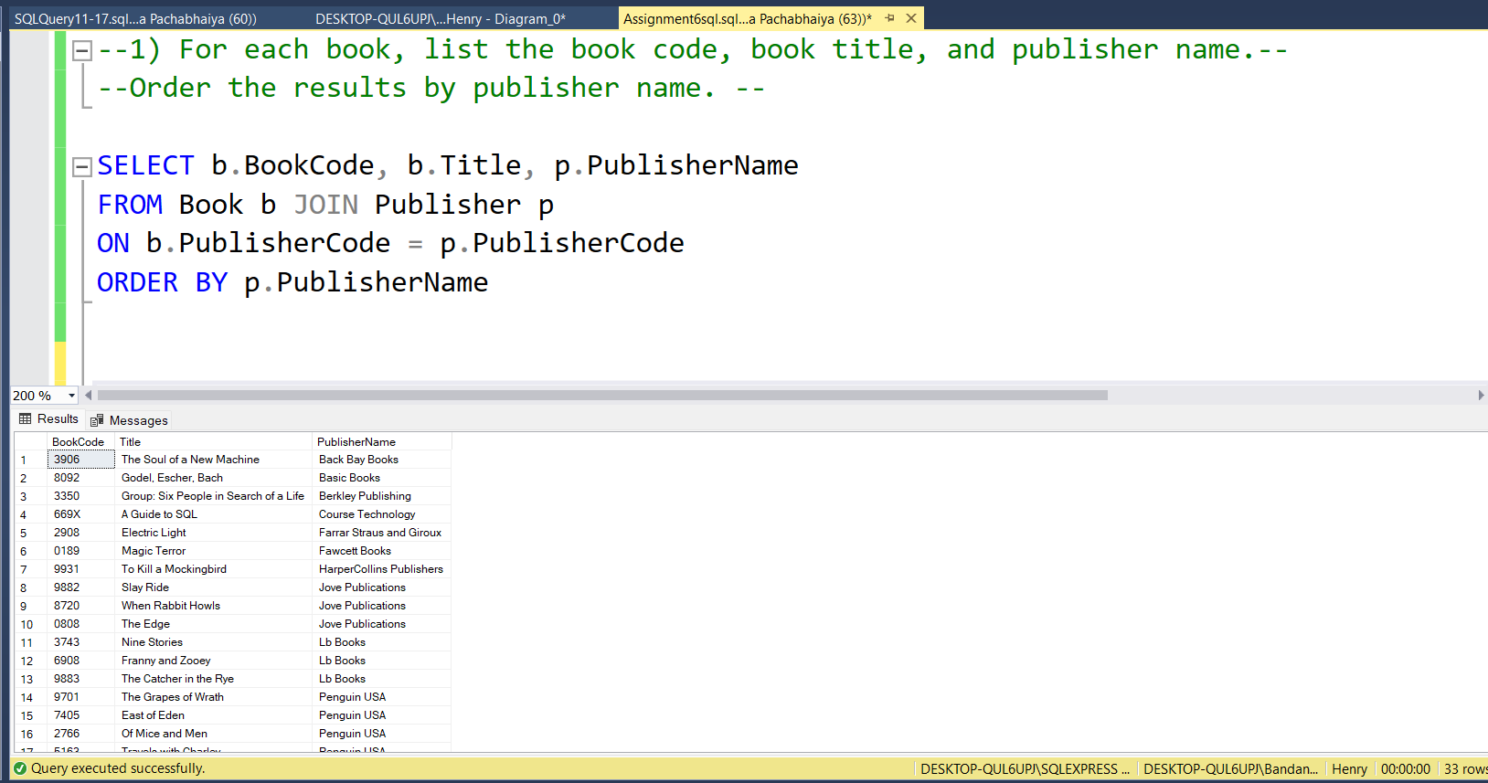

**Question 2:**

For each book published by Scribner, list the book code, book title, and price.

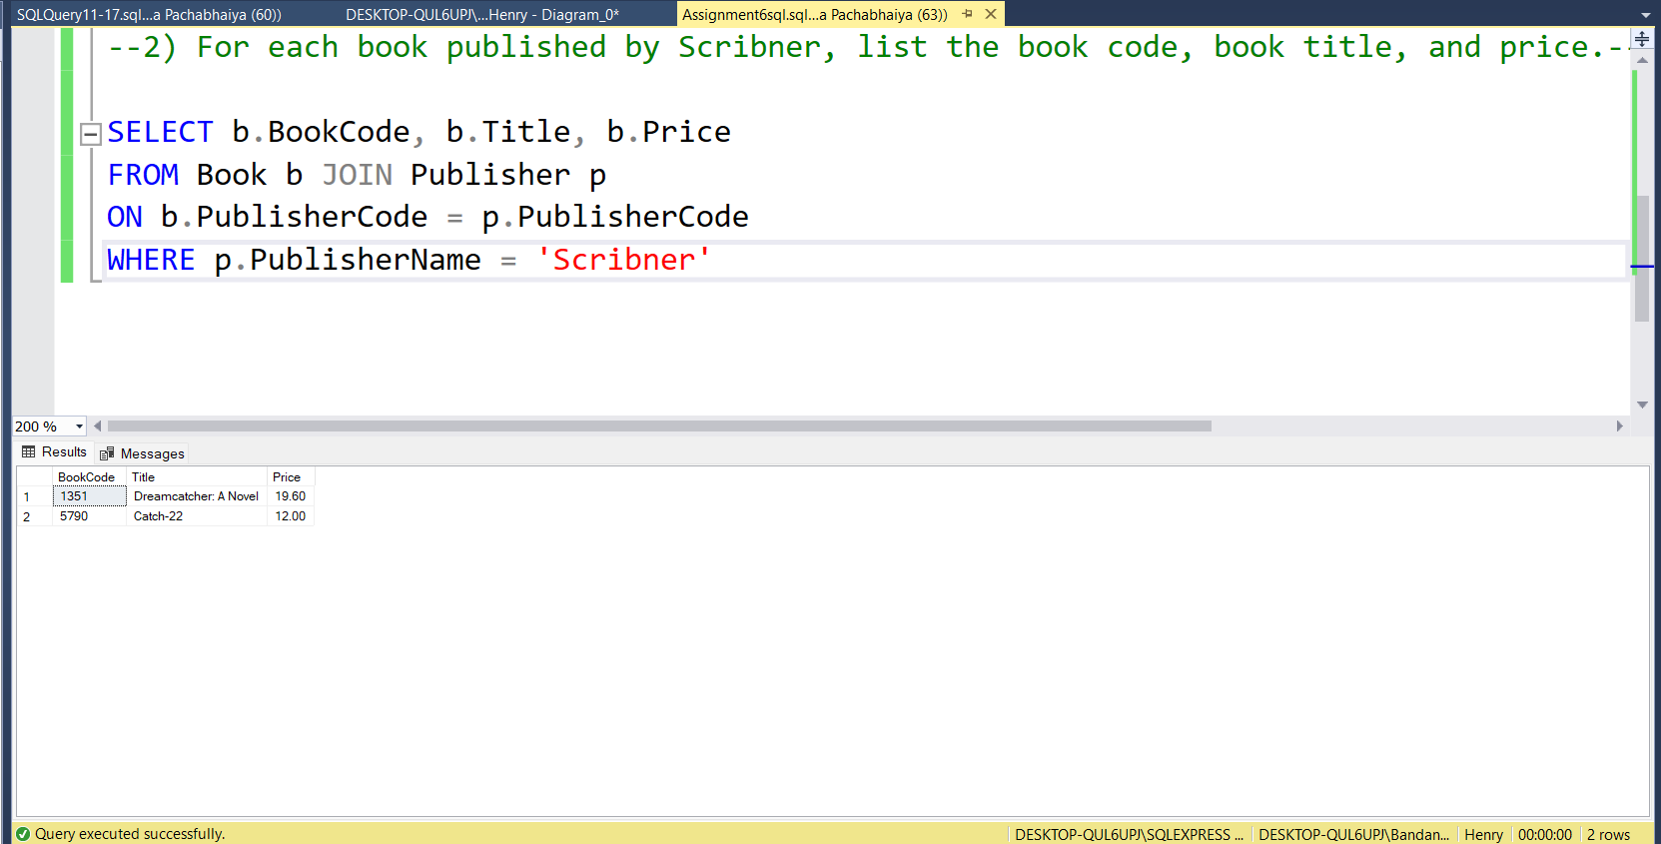

**Question 3:**

List the book title, book code, and price of each book published by Scribner that has a book price of at least $14.

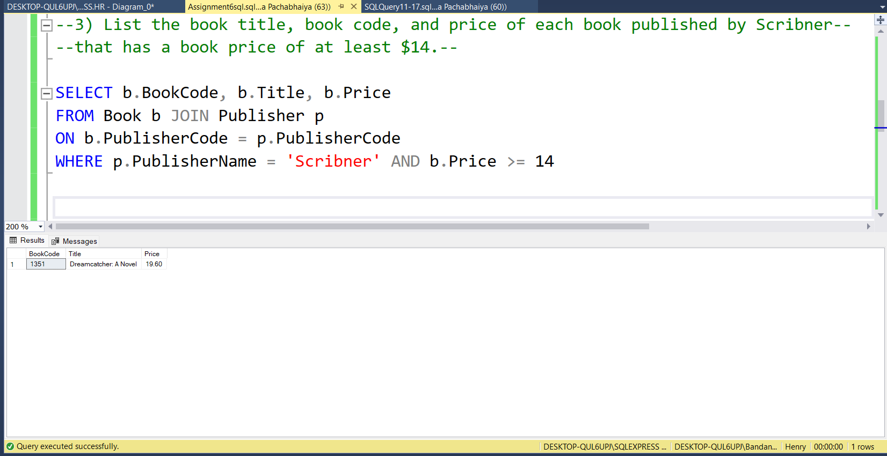

**Question 4:**

**For the following question, use HR database:**

List all employees (first and last name), their department name, and the country, sorted by country.

